**A survey of job recommender systems**

**INTRODUCTION:**

A huge volume of job descriptions and candidate resumes are becoming available online. This vast volume of information gives a great opportunity for enhancing the matching quality; this potential is unused since search functionality in recruiting applications is mainly restricted to Boolean search method. The need increases for applying the recom-mender system technologies that can help recruiters to handle this information efficiently Many researches have been conducted to discuss different issues related to the recruiting problem as well as, the application of recommender system technologies. However, job recommendation is still a challenging domain and a growing area of research.

**MOTIVATION OF JOB RECOMMENDER SYSTEMS:**

The major challenge faced e-recruiting applications as identified by the literature analysis is the large number of low qualification of applicants that match the search criteria.

Since the previous job recommendation systems didn’t adopt the cloud methodologies, its less efficient and have probability of recommending the suitable job for the user. But in our project, we utilize the cloud methodology approach for job recommendation, our system delivers the most suitable job recommendation for the user.

**E-recruitment platforms:**

The e-recruitment is a system for quickly reaching a large set of potential job-seekers. E-recruiting has attractive growth since the late 1990s when the rapid economy changes produced a high demands for qualified candidates that the labor market could not fully satisfy. The e-recruiting platforms such as corporate homepages and job portals have driven this development.

**Categories of E-recruitment platforms:**

Here, job-seekers search jobs by category such as experience, location, education or any combination of these attributes, recruiters search applicants databases by skills, experience, preference, education, salary or any combination of key words.

E-recruiting application service providers present a collection of services such as recruitment software, recruitment process management, education and training.

Corporate career website is an employment source most commonly used by Fortune 500 companies where the use of the corporate career website is a regular extension of e-business applications.

**JOB RECOMMENDATION SYSTEMS**

Most companies put the focus on their own e-recruiting platforms as primary recruitment channels. Job ads are published automatically on the job portal as soon as they are entered into the system. On the other hand, the applicant creates a profile to apply it for one of the listed job positions. The user profile is stored in the system, letting the applicant reuse it for other job position. The last functionality gives the companies possibility to create the applicants pool. Thus, the companies achieved a uniform view for all applicants‟ data in one candidate pool. This pool is used by the recruitment department to find the applicant documents. Appropriate applicants‟ documents are directed to the human resource departments for more processing. In addition, the system supports all required communication processes as well as tracks applicant status inside the application process. The e-recruiting platforms are usually based on Boolean search and filtering techniques that cannot sufficiently capture the complexity of a person-job fit as selection decisions. Many literatures have been applied the recommender system concept into the job problem. Determined that, we must consider unary attributes such as individual skills, mental abilities and personality that control the fit between the individual and the tasks to be accomplished, as well as the relational attributes that determine the fit between the individual and the upcoming team members.

**METHODS:**

**Knowledge-based approach:**

This type of recommender systems attempts to suggest objects based on inferences about users needs and preferences. This approach assists users in the determination of suitable solutions from complex product and service assortments. These solutions based on exploiting deep knowledge about the product domain to figure out the best wishes of the customer. In Knowledge-based recommendation techniques, the relationship between customer requirements and products can be explicitly modeled in an underlying knowledge base. They can use rules and patterns to recommend items based on functional knowledge of how a specific item meets a particular user need. Knowledge-based recommendations perform reasoning about what products meet the user‟s requirements by employing techniques such as a quantitative decision support tools.

**JRS using Web scraping:**

This technique came into existence right around the year when the internet was introduced to the world. The data that are available on the internet will be in forms tables, comments, articles, job listing which are embedded in different HTML tags.

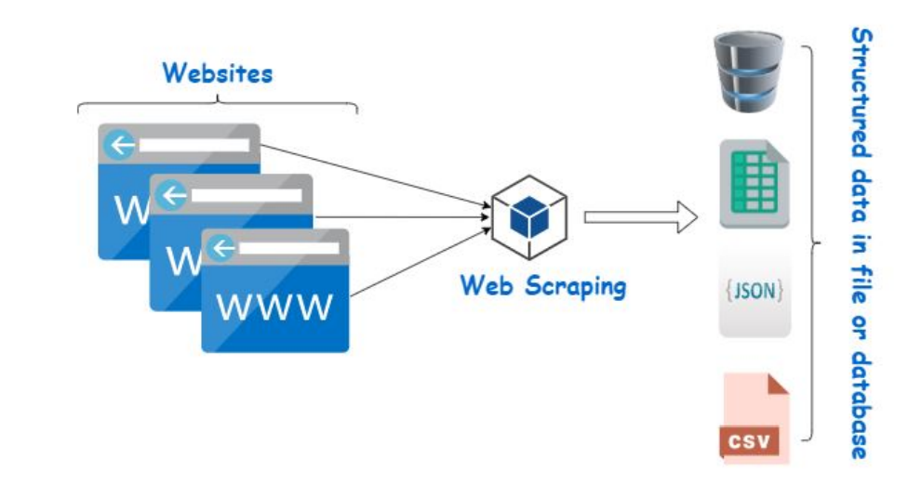

Web scraping is also termed as screen scraping, web data extraction, or even web harvesting. Every website has it's own structure, so the method of web scrapping is hard to generalize for every website. We rely on automating or creating a web crawler using python or R programming language.

**Content-based JRS:**

Content-based recommender systems (CBRs) in the context of JRS are models which, to construct a recommendation, only use a semantic similarity measure between the user profile and the set of available vacancies. I.e., the semantic similarity is used as a proxy for estimating the relevance of each vacancy to the job seeker. In CBRs, one creates vector representations of the vacancy and user profile in an unsupervised way, i.e., the dimensions of these representations may not have an intuitive interpretation.

**Collaborative Filtering (CF):**

CF is a popular recommendation algorithm that bases its predictions and recommendations on the ratings or behavior of other users in the system. There are two basic types: User-based CF and Item-based CF.

• User-based CF

• Item-based CF

**System requirements for candidates/job recommendation:**

There are major requirements presented in literatures that should be derived when recommending candidates for a specific job.

1. The matching of individuals to job depends on skills and abilities that individuals should have.

2. Recommending people is a bidirectional process that needs to consider the preferences not only of the recruiter but also of the candidate.

3. Recommendations should be based on the candidate attributes, as well as the relational aspects that determine the fit between the person and the team members with whom the person will be collaborated.

4. Individual is unique; we cannot choose a single person several times such as a movie or book.

**The Conclusion:**

In this article, we used a literature analysis of many journals and proceedings related to the recruiting process and the job recommendation researches. We have seen from our literature review and from the challenges that faced the holistic e-recruiting platforms, an increased need for enhancing the quality of candidates/job matching. The recommender system technologies accomplished significant success in a broad range of applications and potentially a powerful searching and recommending techniques. Consequently, there is a great opportunity for applying these technologies in recruitment environment to improve the matching quality. This survey shows that several approaches for job recommendation have been proposed, and many techniques combined in order to produce the best fit between jobs and candidates.

As part of our ongoing research, we aim to build a new recommendation approach using python flask and cloud technologies and test with real data for employee and staffing data from large companies. In addition to, we plan to enhance the similarity measures that suitable for this problem.

**Existing platform:**

Glassdoor

LindedIn

Indeed

Upwork

Monster.com

Fiverr

Naukri.com

**References:**

<https://www.researchgate.net/publication/272802616_A_survey_of_job_recommender_systems>

<https://esource.dbs.ie/bitstream/handle/10788/4254/msc_jeevankrishna_2020.pdf?sequence=1&isAllowed=y>

<https://www.irjet.net/archives/V4/i5/IRJET-V4I5343.pdf>

<https://citeseerx.ist.psu.edu/viewdoc/download?doi=10.1.1.369.6535&rep=rep1&type=pdf#page=72>

<https://academicjournals.org/journal/IJPS/article-full-text-pdf/B19DCA416592>